CENWP-ODJ 4/21/2023

MEMORANDUM FOR THE RECORD

SUBJECT: 23JDA12 Spill Impacted by MU-5 Testing

On Wednesday 20 April 2023, at approximately 11AM, MU-5 ran at 150MW for unit testing. The testing concluded on Thursday 21 April 2023, at approximately 6AM (19-hours). During this time the project’s generation flow exceeded the 50-60 KCFS permitted, per the FPP, for 6-block hours (see table 1) (ranges were 63.6 – 64.8 KCFS).

Basic Spring Spill Standards for JDA:
Spring Spill: [16 hours/day: 125% Gas Cap] [8 hours/day: 32% Performance Standard]
Minimum Generation Flow: 50-60 KCFS

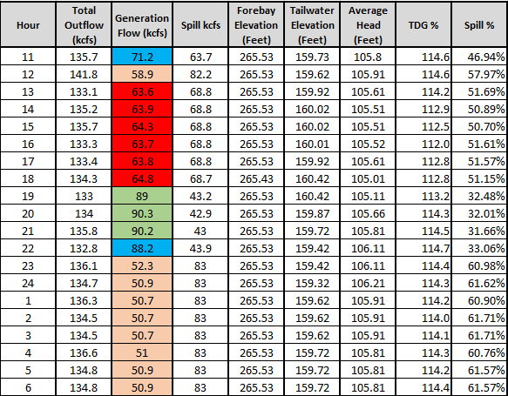
Table 1: Table showing flows at JDA during MU-5 testing window. Areas highlighted red are when generation flows were outside of 50-60 KCFS limit allotted by the FPP. The green cells are during the performance standard window, and the blue cells are transitioning out of the performance standard.

- Species – Unknown, although SMF personnel collected juvenile Chinook, steelhead, and lamprey during this time.
- Origin – Unknown
- Length – Unknown
- Marks and tags – NA
- Marks and Injuries found on carcass – NA
- Cause and Time of Death – NA
- Future and Preventative Measures – Fisheries personnel will coordinate with operations/maintenance crews to determine when units are being tested and ensure power generation/spill volumes are kept in criteria during this time. Additionally, fisheries personnel can note the “generation flows” when spill percentages are above 32% (Performance Standard) to ensure they are within FPP guidelines.

Sincerely,
Project Fisheries

Additional information from JDA Fish –
-----Original Message-----
From: Grosvenor, Eric G CIV USARMY (USA) <Eric.Grosvenor@usace.army.mil>
Sent: Monday, April 24, 2023 7:07 AM
To: Lotspeich, Michael D CIV USARMY CENWP (USA) <Michael.D.Lotspeich@usace.army.mil>; Mackey, Tammy M CIV USARMY CENWP (USA) <Tammy.M.Mackey@usace.army.mil>
Subject: RE: Region is asking what happened yesterday with spill.

Good Morning,

I just talked with our chief of operations and he said they did coordinate with BPA on the variance to minimum generation for the reduction in spill. Here's the language in the FPP to explain this. Typically, it's a non-issue as there's plenty of water and we're not operating with minimum generation, but with the higher gas caps, we'll probably run into this again so we'll keep an eye on things.

4.3.3. Operational Testing. Some types of turbine maintenance require testing turbine operation throughout its full range before and after maintenance. Operational testing of a unit under maintenance is in addition to a unit in run status required for power plant reliability. Operational testing may deviate from FPP priority order and may require water that would otherwise be used for spill if the project is operating at minimum generation requirements. Water for operational testing will be used from powerhouse allocation when possible and diverted from spill only to the extent necessary to maintain generation system reliability.

-Eric

